

Department of Microbiology

484 West 12th Avenue
Columbus, OH 43210-1292

Phone (614) 292-2301
Fax (614) 292-8120

December 16, 2010

Professor Larry Krissek
Chair, Arts and Sciences CCI
Re: Department of Anthropology Minors

Dear Professor Krissek:

At the November 29, 2010 meeting of the Mathematics and Social, Behavioral, and Natural Sciences CCI Subcommittee the semester conversion plans for the Anthropology Minor and the Forensic Science minor, submitted by the Department of Anthropology, were reviewed. The Anthropology minor program consisted of three sub-plans: Physical Anthropology, Cultural Anthropology and Archaeology. These plans were well organized and represented direct conversions from the existing schemes. We noted that there was a change in the administration of the Forensic Science minor. Previously this was an interdisciplinary minor, this program is now formally associated with the Department of Anthropology. The Forensic Science minor program remains essentially unchanged, with the exception of ANT2200 (Introduction to Physical Anthropology), which will be presented as a laboratory course in its semester form. We felt that both proposals presented comprehensive descriptions of their programs and that current students could readily transition to the new plans. For clarity, we requested comments on a number of minor points in the text. These are described below.

For the Anthropology program:
- We noted a text error: In the list of Cultural Anthropology semester courses, Anthropology 597.05H should read 4597.05H.

For the Forensic Science program:
- A semester number is needed for ASC 211.
- Does ASC 211 represent a required course “outside of the unit”? If so, credit hours associated with this course should be reflected in the PACER form in this category.
- Are the successor course number and its semester credit value known for Pharmacy 200?
- Under point “III. List of Semester Courses in the program”: “The Forensic Science minor requires the completion of (15 hours?), which consists of an introductory course (3 hours), a required foundational course (3 hours) and two of three core courses.” Delete “of three” since under semesters there will be five core courses (there were three under quarters).
- Under point “III. List of Semester Courses in the program” and on the Semester Advising Sheet, clarify following reference: (15 hours?).

Since these revisions were viewed as minor, the subcommittee unanimously approved both proposals and we have submitted them for the next step in the approval process.

Sincerely,
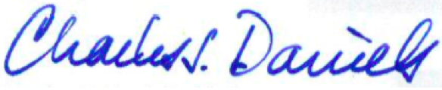

Charles J. Daniels, Ph.D.
Professor
Acting Subcommittee Chair for Nov. 29

